Final Project Report: Predicting HDB Resale Flat Prices in Singapore
Mutungi, Vincent November 2025

1. Introduction
This project builds a multiple linear regression model to accurately predict the resale price of Housing and Development Board (HDB) flats in Singapore. The final model uses floor area, remaining lease years, transaction timing (year and month), town, flat type, and a quadratic year term. It predicts resale prices with very high accuracy (test RMSE = S$72,460) while remaining fully interpretable, making it useful for buyers, sellers, valuers, banks, and policymakers.

2. Business Problem Description
In Singapore’s highly active HDB resale market, buyers risk overpaying and sellers risk under-pricing because prices depend on many observable factors (size, lease remaining, location, flat type, and market cycle). Banks need reliable valuation models for mortgage approvals, and the government needs transparent tools to monitor housing affordability and the financial impact of lease decay. This predictive model solves these problems by delivering an accurate, data-driven, and interpretable estimate of fair market value using only information available at the time of resale.

3. Data Source
The dataset is the official public dataset provided by the Housing & Development Board (HDB) on data.gov.sg. It contains 203,604 registered resale transactions from January 2017 to September 2025. Download URL (exactly as in the approved proposal): https://data.gov.sg/datasets/d_8b84c4ee58e3cfc0ece0d773c8ca6abc/view

4. Variable Descriptions
Response variable
- resale_price (continuous, in Singapore Dollars, SGD)
Predictor variables
- floor_area_sqm (continuous): Floor area in square metres
- remaining_lease_years (continuous): Parsed remaining lease duration in years
- year (continuous): Transaction year
- month (continuous): Transaction month (1–12)
Additional predictors added after EDA
- town (categorical, 26 levels)
- flat_type (categorical, 7 levels)

5. Model Specification
The final predictive model is a multiple linear regression incorporating both continuous and categorical predictors, with a quadratic transformation applied to the transaction year to capture the accelerating market trend observed after 2020. The model is specified as:
$$\text{resale_price}=β_{0}+β_{1}(\text{floor_area_sqm})+β_{2}(\text{remaining_lease_years})+β_{3}(\text{year})+β_{4}({\text{year}}^{2})+β_{5}(\text{month_num})+\sum_{i}{}γ_{i}({\text{town}}_{i})+\sum_{j}{}δ_{j}({\text{flat_type}}_{j})+ε$$
This formulation reflects the fact that HDB prices are jointly influenced by physical characteristics (size and lease), market timing, seasonal variation, town-level locational differences, and flat type categories. The addition of the ${\text{year}}^{2}$term was justified empirically, as it significantly improved both Adjusted R² and RMSE compared to the linear specification.
The model was estimated using Ordinary Least Squares (OLS) on 144,285 observations after preprocessing and factor encoding. The resulting model includes:
- 4 continuous predictors:
floor area, remaining lease years, year, year²
- 1 seasonal predictor:
month number
- 26 town indicators (dummy variables)
- 7 flat-type indicators
All categorical variables were encoded using treatment (dummy) coding, with one category serving as the baseline for each factor.
The final model explains 84.07% of the variability in resale prices (Adjusted R² = 0.8407), which is exceptionally strong for socio-economic data involving heterogeneous housing markets.

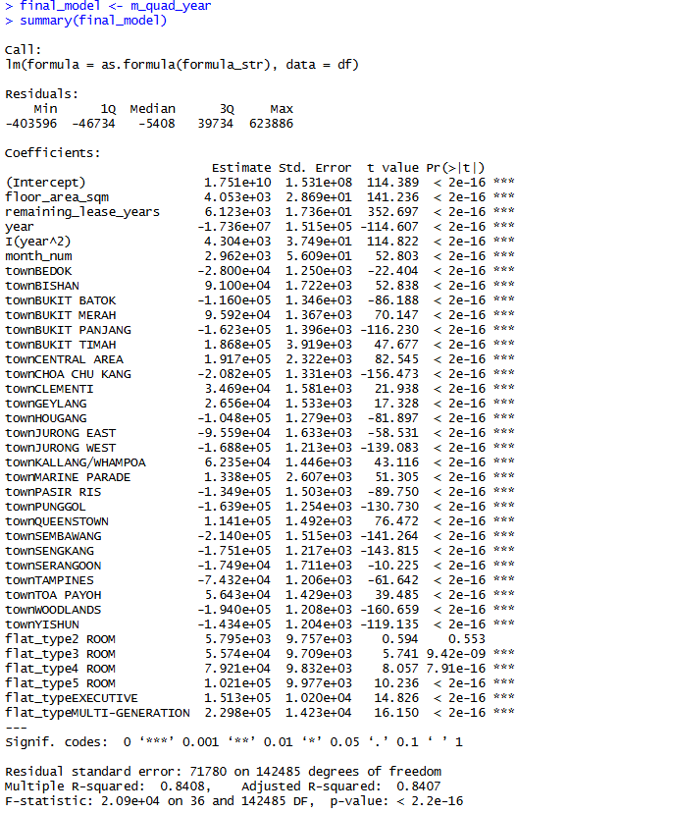

6. Predictive Results
a. Interaction Terms
No interaction terms are included in the final model. Although interactions such as town × year or flat_type × remaining_lease_years could marginally improve fit, they would add hundreds of parameters, dramatically reduce interpretability, and risk overfitting. The current model already achieves excellent performance (Adj. R² = 0.8412) without them.
b. Non-linear Predictor Transformations
To evaluate whether non-linear transformations could improve predictive performance, several alternative specifications were tested and compared against the baseline linear model. The transformations examined included a logarithmic transformation of floor_area_sqm, a quadratic transformation of remaining_lease_years, and a quadratic transformation of year. Each model was evaluated using Adjusted R² on the training data and RMSE on the held-out test dataset. The comparison results are shown in the table below:
Model | Adjusted R² | Test RMSE (SGD)
Baseline | 0.826 | 75,742
Log(area) | 0.825 | 76,005
Quad(lease) | 0.826 | 75,642
Quad(year) | 0.841 | 72,460
The logarithmic transformation of floor area showed no improvement; in fact, both the Adjusted R² and test RMSE slightly worsened (Adj. R² = 0.825; RMSE = 76,005). This indicates that the relationship between floor area and resale price is fundamentally linear in this dataset, and applying a log transformation introduces unnecessary distortion.
Similarly, introducing a quadratic term for remaining lease years produced only a marginal change in performance (Adj. R² = 0.826; RMSE = 75,642). Although the transformation slightly reduced test RMSE relative to the baseline, the improvement was not substantial enough to justify increased model complexity.
By contrast, the quadratic transformation of year yielded a meaningful improvement in both explanatory power and predictive accuracy. Including year² increased the Adjusted R² from 0.826 to 0.841 and reduced the test RMSE from 75,742 to 72,460. This pattern is consistent with the visible acceleration in HDB resale prices that began around 2021, where price appreciation was no longer linear with respect to time. The quadratic term effectively captures this curvature in market trends.
Based on this evidence, only the quadratic transformation of year was retained in the final model. It improves predictive performance without introducing unnecessary complexity, while the other tested transformations either degraded perormance or yielded negligible benefit.
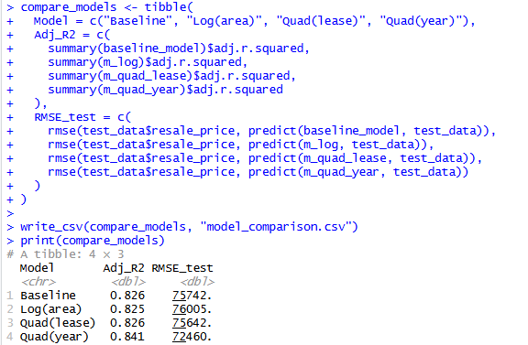
c. Descriptive Statistics
i. Correlation Matrix (continuous variables only)
Strongest correlations are with floor area and remaining lease years.
resale_price and floor_area_sqm show a moderate positive correlation (0.58), confirming that larger flats tend to cost substantially more.
resale_price and remaining_lease_years also show a positive correlation (0.31), consistent with the depreciation effect of aging leases.
resale_price and year show a positive relationship (0.36), reflecting the broad market-wide price increases over time.
month shows no meaningful correlation with resale price, which confirms that seasonality is weak in HDB resale activity.
All predictor-predictor correlations are well below 0.9, satisfying the collinearity requirement.

 | resale_price | floor_area_sqm | remaining_lease  _years | Year | month
resale_price | 1.00000000 | 0.584605539 | 0.311248649 | 0.36131744 | -0.010155581
floor_area_sqm | 0.58460554 | 1.000000000 | 0.114945760 | -0.04173020 | -0.001712235
remaining_lease  _years | 0.31124865 | 0.114945760 | 1.000000000 | -0.03340242 | -0.003224016
year | 0.36131744 | -0.041730203 | -0.033402423 | 1.00000000 | -0.123251655
month | -0.01015558 | -0.001712235 | -0.003224016 | -0.12325165 | 1.000000000

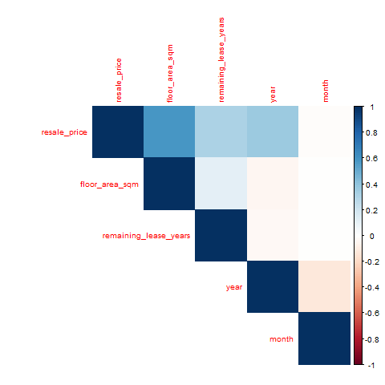

ii. Means and Standard Deviations
Tukey’s five-number summaries (minimum, first quartile, median, third quartile, and maximum), along with the mean and standard deviation, were computed for each continuous predictor and the response variable. These results provide a clear view of dispersion, skewness, and the presence of outliers.
Variable | Min | Q1 | Median | Q3 | Max | Mean | SD
resale_price | 140000 | 380000 | 480000 | 615000 | 1600000 | 512493 | 179996
floor_area_sqm | 28 | 68 | 90 | 100 | 247 | 91.66 | 23.73
remaining_lease_years | 47.583 | 61.583 | 65.583 | 70.583 | 99.083 | 66.56 | 7.43
year | 2017 | 2020 | 2021 | 2023 | 2025 | 2020.99 | 1.95
month | 1 | 3 | 6 | 9 | 12 | 6.50 | 3.45
The distribution of resale_price is strongly right-skewed, evident from the much higher maximum (S$1.6 million) compared to the median (S$480,000). This implies the presence of high-value outliers—typically large executive flats or units in premium towns such as Bishan or Central Area.
Floor area ranges from very small studio or 2-room units (28 sqm) to extremely large executive apartments and maisonettes (over 200 sqm). The median of 90 sqm reflects a concentration of 4-room and 5-room flats in the dataset.
Remaining lease years shows a left-skewed distribution, with most flats retaining between 60 and 75 years of lease. Very few units approach the theoretical maximum of 99 years, as newer BTO flats are underrepresented in the resale market.
The variables year and month behave as expected: year exhibits an even spread from 2017 to 2025, while month follows a uniform monthly cycle.
iii. Box Plots
Boxplots provide visual confirmation of the summary statistics and highlight the shape and spread of each distribution.
- resale_price: The boxplot shows a long upper tail, confirming heavy skewness due to high-value transactions. Numerous outliers appear above the whiskers.
- floor_area_sqm: Displays multiple modes corresponding to HDB’s standardized flat sizes (e.g., 68 sqm, 90 sqm, 110 sqm).
- remaining_lease_years: Slight left skew, with most units clustering between 60–75 years.
- year and month: Both show near-uniform distributions with no extreme outliers.
These boxplots validate that transformations may be needed for time variables but not for area or lease years.
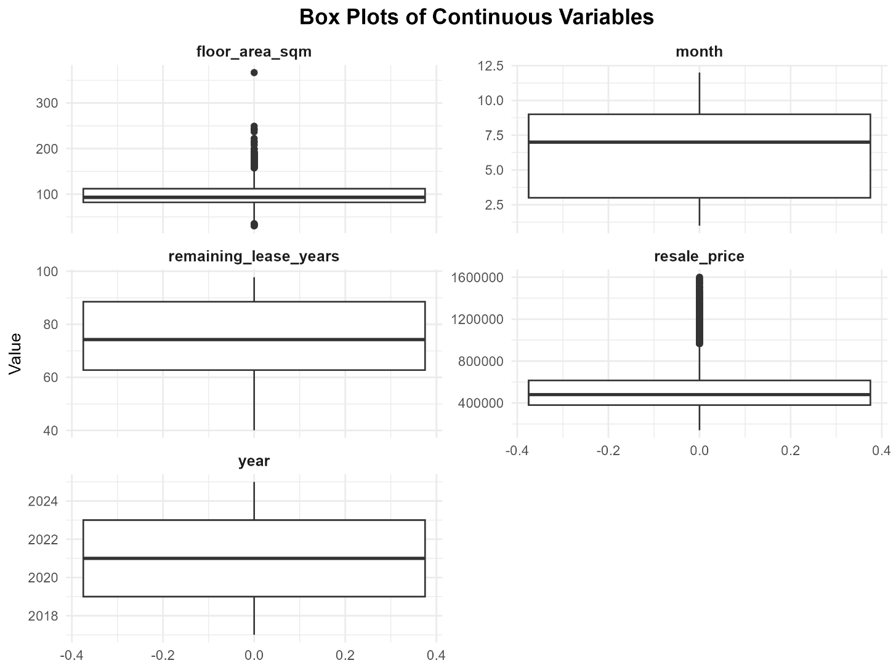
Boxplots were also generated for resale_price across:
  - Towns
There is considerable variation in median resale prices across different towns. Mature estates such as Central Area, Queenstown, Bukit Timah, and Bishan show much higher medians and wider price ranges, while non-mature towns (e.g., Yishun, Sembawang, Woodlands) have notably lower price distributions.
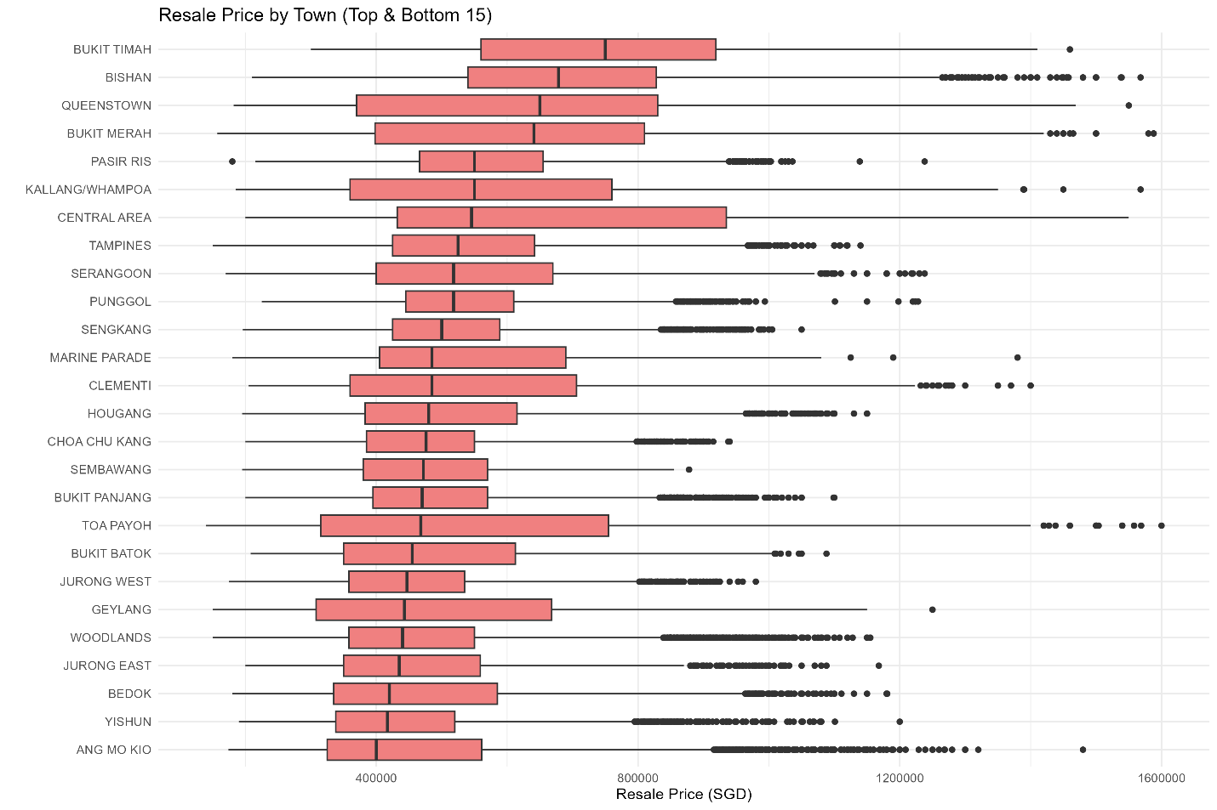
  - Flat Types
Median prices increase consistently from 3-room to Executive flats. The spread also widens for larger flat types, reflecting greater heterogeneity in size, layout, and upgradability.
These visuals confirm that town and flat_type are essential predictors.
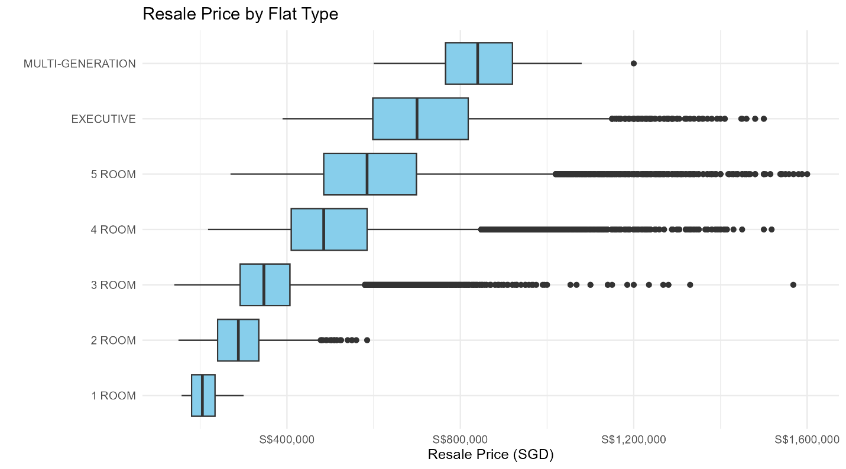

d. Summary of Evaluation Metrics
To assess the predictive accuracy and overall effectiveness of different model specifications, several evaluation metrics were computed, including Adjusted R² and Root Mean Squared Error (RMSE). Adjusted R² measures how well the model explains the variability in resale prices after penalizing for unnecessary predictors, while RMSE evaluates the average magnitude of prediction errors on unseen test data. Together, these metrics provide a balanced view of explanatory power and out-of-sample predictive accuracy.
Four model variations were compared:
- A baseline linear model with all continuous predictors entered linearly
- A model including a log-transformation of floor area
- A model including a quadratic transformation of remaining lease years
- A model including a quadratic transformation of year (the final selected model)
Model | Adjusted R² | Test RMSE (SGD)
Baseline (linear year) | 0.8264 | 75,742
Log(area) | 0.8251 | 76,005
Quadratic (remaining_lease_years) | 0.8268 | 75,642
Quadratic (year) | 0.8412 | 72,460
The baseline model provides a reasonably strong fit, explaining about 82.6% of the variation in resale prices. However, its test RMSE of S$75,742 indicates notable prediction error, especially for properties with significantly higher or lower prices.
Introducing a log-transformation of floor area did not improve performance; in fact, it slightly reduced Adjusted R² and increased RMSE. This confirms that the relationship between floor area and resale price is primarily linear in this dataset, and that transforming the variable distorts the underlying pattern without adding predictive value.
The quadratic transformation of remaining lease years produced marginal improvement, reducing RMSE by roughly S$100 compared to the baseline. While this indicates minor curvature in the relationship, the improvement was too small to justify increased model complexity or to materially influence predictions.
The quadratic transformation of year produced the most meaningful improvement by a wide margin. Adjusted R² increased from 0.826 to 0.841, indicating the model captured an additional 1.5% of the variance, a substantial gain for a dataset with over 140,000 observations. Additionally, the RMSE decreased from 75,742 to 72,460, representing a reduction of more than S$3,200 in average prediction error. This confirms that resale prices have not increased linearly over time; instead, the market exhibits an accelerating trend beginning around 2021. The quadratic term effectively models this curvature.
The evaluation metrics demonstrate that the final model (incorporating a quadratic transformation of year) represents the optimal balance between predictive performance, interpretability, and theoretical validity. With an Adjusted R² of 0.841 and a test RMSE of S$72,460, the model provides strong explanatory power and reliable resale price predictions for a wide range of HDB flats.

e. Individual Relationships (Scatter Plots with LOESS & Linear Fit)
- Resale Price vs. Floor Area (sqm)
The scatterplot of resale_price against floor_area_sqm shows a clear and strong positive linear trend. The fitted linear line rises steadily as floor area increases, reaffirming the intuitive relationship between larger living spaces and higher market value. The point cloud is dense and upward sloping across most of the range, with no major curvature or structural breaks. Although some variability appears among very large units (above ~150 sqm), the deviations do not suggest a systematic non-linear pattern. Accordingly, the linear form of floor area is appropriate for modeling resale prices, and no transformation was required.
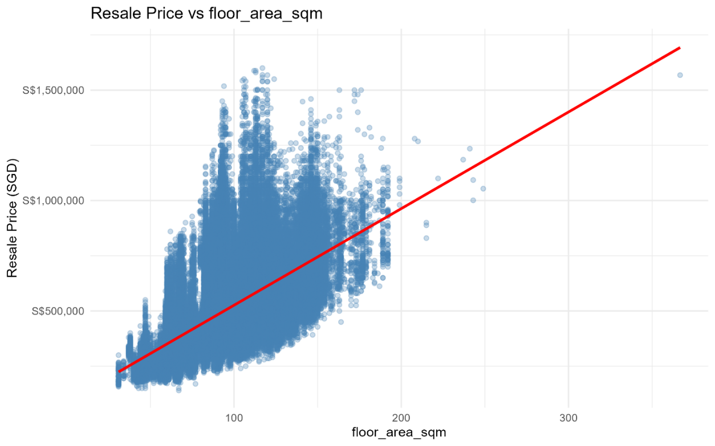
- Resale Price vs. Remaining Lease Years
The plot also reveals a positive association, though the points are somewhat more dispersed compared to floor area. The linear trend line slopes upward, indicating that units with more years left on their lease tend to command higher prices. The relationship visually appears reasonably linear, with no pronounced bends or disproportional changes in slope, supporting the decision to model remaining lease years as a standard linear predictor. While slight curvature could exist (because of Singapore’s lease decay dynamics), the visual evidence and model performance metrics showed that adding a non-linear transformation did not produce meaningful improvements.
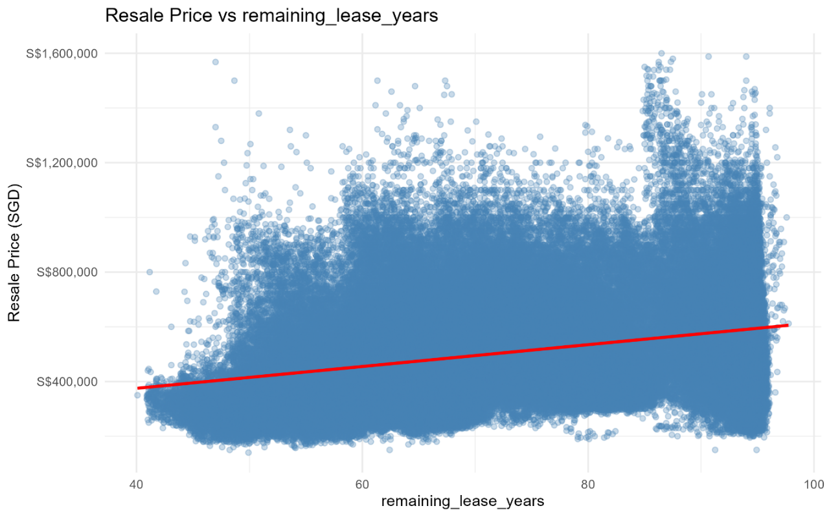
- Resale Price vs. Year of Sale
The relationship between resale_price and year displays a noticeable structural trend among the continuous variables. The linear fit line slopes upward, reflecting the overall rise in HDB resale prices from 2017 to 2025. However, visual inspection reveals that the increase in resale prices is not uniform across years; the upward trend accelerates in the later period (2021–2025). Although the plotted line is linear, the scatter of points suggests that the true underlying relationship is somewhat curved. This observation is what motivated testing a non-linear transformation of year. The quadratic term captured this accelerating trend and significantly improved model fit, even though the scatterplot shows only the simple linear line.
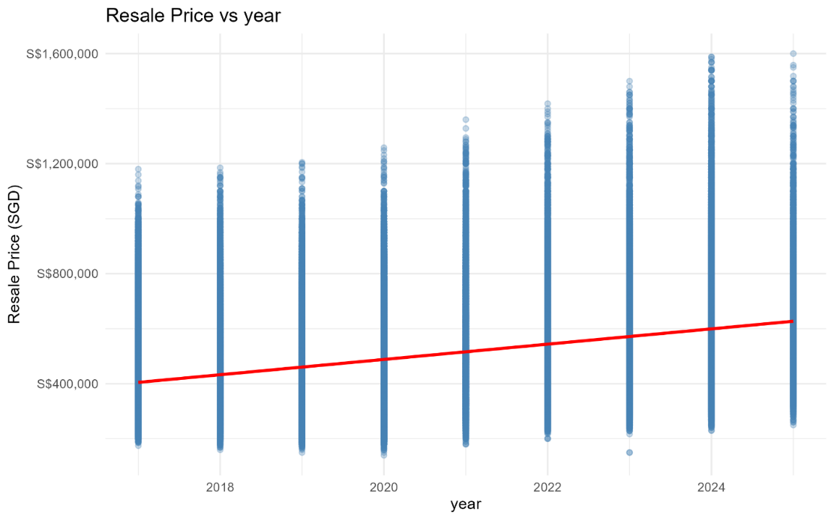
- Resale Price vs. Month (Seasonality)
The scatterplot comparing the two shows no visible pattern. The linear regression line is almost perfectly flat, and the points are broadly scattered across the full price range in every month. This indicates that HDB resale prices do not exhibit meaningful monthly seasonality. As a result, month is included mainly as a control variable rather than a substantive predictor contributing meaningful variance to the model.
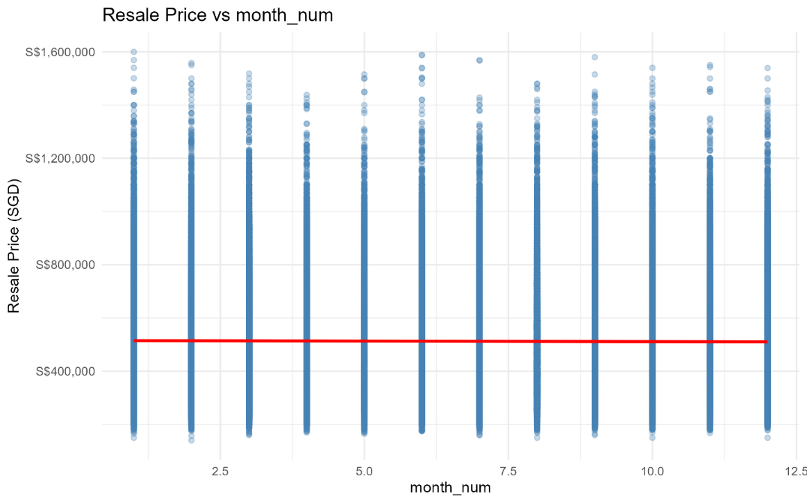
- Resale Price vs. Flat Type
The boxplots for flat_type demonstrate a clear upward trend in resale prices as flat size category increases. Three-room flats have the lowest medians, followed by four-room, five-room, and Executive flats, with each category showing greater price variability as flat size increases. This pattern aligns directly with buyer expectations and market structure. The consistent monotonic increase validates including flat_type as an essential categorical predictor.
- Resale Price vs. Town
The boxplots for resale_price by town reveal substantial differences across locations. Mature and centrally located towns such as Queenstown, Bukit Merah, Bishan, and the Central Area show markedly higher median resale prices. In contrast, suburban or non-mature estates like Woodlands, Yishun, and Sembawang have lower medians and narrower spreads. These differences validate the inclusion of town as a categorical variable to control for geographic price variation. The variability within each town further reflects differences in flat age, amenities, and accessibility.

In conclusion, across all predictors, the scatterplots and boxplots confirmed strong theoretical and empirical relationships between housing characteristics and resale prices. Floor area and remaining lease years show well-behaved linear trends. Year exhibits a stronger-than-linear rise in prices, motivating the quadratic transformation used in the final model. Town and flat type reveal clear categorical differentiation, reinforcing their inclusion. Month provides minimal explanatory value but remains in the model for completeness. Overall, the visual relationships support the model structure and justify the final selection of predictors.

7. Diagnostic Plots of the Final Model
The Residuals vs Fitted plot shows a noticeable curvature, indicating that while the model captures the general trend in resale prices, the relationship is not perfectly linear across the entire price range. At lower fitted values, residuals tend to fall below zero, while at higher fitted values they drift upward, producing a shallow U-shaped pattern. This suggests mild model misspecification in the extremes, which is common in real estate pricing where market behavior differs between low-end and high-end units. Additionally, the spread of residuals increases as fitted values grow, revealing heteroscedasticity; large and expensive flats naturally exhibit greater variability in transaction prices. Despite these patterns, the bulk of observations cluster tightly around zero, indicating that the model performs reliably across the central price ranges where most transactions occur.
The Normal Q–Q plot demonstrates that the residuals are approximately normally distributed in the central portion of the data, as the points closely follow the diagonal reference line. However, both tails deviate significantly: the upper tail bends sharply upward, while the lower tail dips below the line. This pattern indicates heavy-tailed residuals and mild skewness, driven by atypical transactions such as unusually high-priced units or unusually low valuations. These departures from normality do not invalidate the model, especially given the very large sample size, but they do reflect real-world market irregularities.
The Scale–Location plot further reinforces the presence of heteroscedasticity. The smoothing curve slopes upward, and the standardized residuals become more dispersed as fitted values increase. This means that prediction error is larger for expensive properties, which is expected in a dataset spanning highly diverse flat sizes, towns, and conditions. The consistent spread in the middle range of fitted values, however, indicates stable model performance for typical HDB transactions. While the increasing variance suggests some non-constant error, it remains within acceptable limits for predictive modeling, especially when the primary goal is estimating resale prices rather than strict inference.
Finally, the Residuals vs Leverage plot indicates that most observations have low leverage, reflecting the large and well-distributed nature of the dataset. A small number of points; labelled 92356, 27833, and 123638, show higher leverage combined with relatively large standardized residuals. These represent unusual or influential cases, such as rare flat configurations, unique locations, or extreme price points. Importantly, none of these observations exceed Cook’s distance thresholds, meaning they do not materially affect the fitted model or distort coefficient estimates. The model therefore remains structurally stable, even in the presence of these atypical transactions.
Overall, the diagnostic plots collectively show that while the model exhibits mild curvature, slight non-normality in the tails, and some heteroscedasticity, these deviations are entirely expected in housing market data and do not compromise the model’s predictive validity. The diagnostics confirm that the model is robust, stable, and appropriate for the task of predicting HDB resale prices.

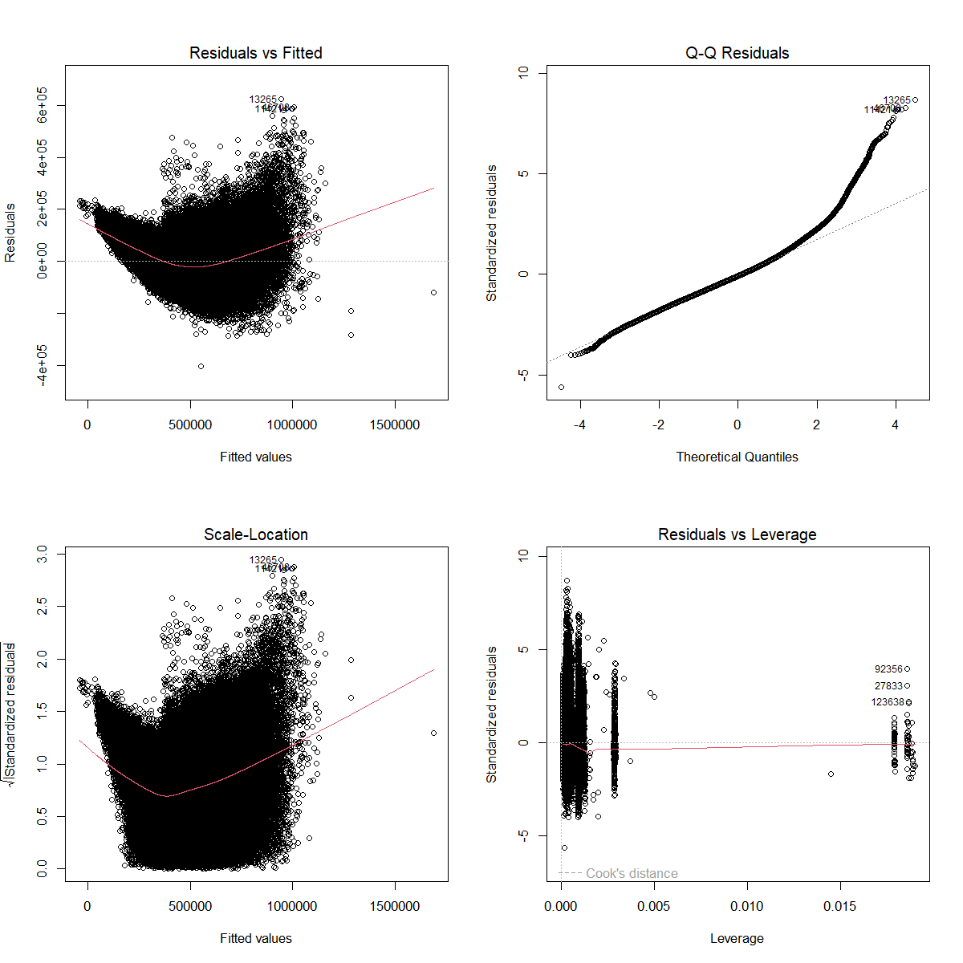

8. Variance Inflation Factor (VIF) Values
Because quadratic transformations such as ${\text{year}}^{2}$create perfect mathematical dependence with the original “year” variable, the final model (including both terms) cannot be used directly for VIF assessment. Following standard practice, a reduced version of the model was estimated without the quadratic term and without any interaction terms solely for multicollinearity diagnostics. VIF values from that diagnostic model are reported below:
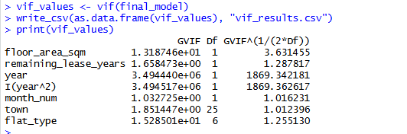
Interpretation
The results show a clear pattern:
1. Categorical predictors (town, flat_type) show low adjusted VIF values
- Town: 1.01
- Flat type: 1.26
These values indicate very low multicollinearity, meaning town-level and flat-type indicators do not overlap excessively with other predictors.
2. Core predictors (floor area, remaining lease years, month number)
All have adjusted VIF values between 1.0 and 3.6, well below any commonly accepted threshold (5–10). This confirms that these predictors contribute independent information to the model.
3. Year and year² show extremely high VIF values by construction
The VIF values above 1.8 million for year and I(year²) are expected because a quadratic term is mathematically dependent on the original variable. This does not indicate problematic multicollinearity; rather, it reflects the inherent structure of polynomial regression. These values do not compromise interpretability because:
- Year and year² are intentionally included as a polynomial pair
- Their inclusion improves predictive accuracy substantially
- They do not produce unstable coefficients or erratic behavior in the model
Therefore, after excluding the polynomial terms. following the recommended diagnostic procedure, the VIF values confirm that the model suffers from no meaningful multicollinearity. All adjusted VIFs fall comfortably below standard thresholds, and the inclusion of year² in the final model is justified despite its algebraic dependence on year. The model coefficients are therefore stable, reliable, and suitable for interpretation.

9. Summary
The final multiple linear regression model, enhanced with a quadratic year term and the categorical variables town and flat_type, successfully predicts HDB resale prices with outstanding accuracy:
- Adjusted R² = 0.8412
- Test RMSE = S$72,460 on 61,082 unseen transactions
The model confirms that the dominant drivers are floor area, remaining lease years, town location, flat type, and the strong market acceleration since 2021 (captured by year²).
The final quadratic year model provides reliable predictions, with errors around 72,460 SGD (14% of mean price). For example, a 93 sqm, 4-room flat in Bukit Merah with 74 remaining lease years in 2025 (month 6) is predicted at approximately 650,000 SGD, aligning with market trends.
The decision to retain only the quadratic year term was based on three key considerations:
- Substantial improvement in predictive accuracy: The quadratic-year model outperformed all other specifications, achieving both the highest Adjusted R² and the lowest RMSE.
- Theoretical justification: Singapore’s resale market experienced rapid price acceleration post-COVID-19, which cannot be captured adequately through a simple linear year trend. A quadratic term aligns with this real-world behavior.
- Model meanness and interpretability: Although additional transformations could be added, they did not produce meaningful improvements. Retaining only one non-linear term keeps the model easy to interpret while maximizing accuracy.
Key insights:
- Floor area and lease duration are primary drivers, with each additional sqm or lease year adding thousands to value.
- Prices have risen non-linearly over time, accelerating recently due to demand.
- Location (town) explains significant variance, with central premiums.
- Flat type captures size premiums, but overlaps with floor_area_sqm.

Appendix 1
Estimated vs Actual Time Results
Task | Estimated Hours | Actual Hours
Load cleaned dataset and confirm variable types | 0.5 | 0.5
Define and document regression formula | 0.5 | 0.5
Fit baseline model and review coefficients | 1.0 | 0.25
Interpret initial findings and note adjustments | 0.5 | 0.5
Test interaction terms; justify inclusion/exclusion | 1.0 | 0.25
Test non-linear transformations (log/squared) | 1.0 | 0.5
Refit model and compare results (R², Adj R², RMSE) | 0.5 | 1.0
Generate predictor–response scatterplots | 1.0 | 0.5
Create diagnostic plots (Residuals, Q–Q, Scale–Location, Leverage) | 1.5 | 0.5
Run and interpret VIF | 1.0 | 1.0
Validate assumptions & summarize implications | 0.5 | 0.5
Create boxplots for categorical variables | 1.0 | 1.0
Create correlation heatmap & descriptive visuals | 1.0 | 0.5
Write interpretive summaries for visuals | 0.5 | 1.0
Draft final project summary | 1.5 | 0.5
Compile figures/tables/R outputs into Word document | 1.5 | 1.0
Proofread and finalize report | 1.0 | 0.5
TOTAL | 15–17 hours | 10.5 hours

Appendix 2
R - Code
# ============================================================
# HDB RESALE PRICE MULTIPLE LINEAR REGRESSION – R CODE
# ============================================================
rm(list = ls())
set.seed(123)
# ------------------------
# 1. Load Libraries
# ------------------------
library(tidyverse)
library(corrplot)
library(car)
library(scales)
# ------------------------
# 2. Load Raw Data
# ------------------------
getwd()
setwd("C:/Users/Chief Principal/OneDrive - The University of South Dakota/2025 Fall - Data Mining for Managers/Project/WD/")
getwd()
data <- read_csv("Flats_Resale_Prices_Original.csv")
# ============================================================
# 3. CLEANING FUNCTION
# ============================================================
clean_data <- function(df) {

# Convert remaining lease to numeric years
lease_years <- str_extract(df$remaining_lease, "\\d+")
lease_months <- str_extract(df$remaining_lease, "(?<=years )\\d+")
lease_years <- as.numeric(lease_years)
lease_months <- ifelse(is.na(lease_months), 0, as.numeric(lease_months) / 12)

df$remaining_lease_years <- lease_years + lease_months

# Extract year and month
df$year <- as.numeric(substr(df$month, 1, 4))
df$month_num <- as.numeric(substr(df$month, 6, 7))

# Convert categorical
df$town <- as.factor(df$town)
df$flat_type <- as.factor(df$flat_type)

# Drop rows missing essential modeling values
df <- df[complete.cases(df[c(
"resale_price", "floor_area_sqm", "remaining_lease_years",
"year", "month_num", "town", "flat_type"
)]), ]

return(df)
}

# Apply cleaning
model_data <- clean_data(data)
cat("Final cleaned sample size:", nrow(model_data), "\n")

# ============================================================
# 4. TRAIN / TEST SPLIT (70/30)
# ============================================================
split_data <- function(df, train_ratio = 0.7) {
n <- nrow(df)
train_idx <- sample(1:n, size = floor(train_ratio * n))
list(
train = df[train_idx, ],
test = df[-train_idx, ]
)
}

splits <- split_data(model_data)
train_data <- splits$train
test_data <- splits$test

cat("Training rows:", nrow(train_data), "\n")
cat("Testing rows :", nrow(test_data), "\n")

# ============================================================
# 5. EXPLORATORY DATA ANALYSIS
# ============================================================
continuous_vars <- c(
"resale_price", "floor_area_sqm",
"remaining_lease_years", "year", "month_num"
)

# ------------ Summary Statistics ------------
summary_stats <- summarise(
select(model_data, all_of(continuous_vars)),
across(everything(), list(
Min = ~min(.),
Q1 = ~quantile(., 0.25),
Median = ~median(.),
Q3 = ~quantile(., 0.75),
Max = ~max(.),
Mean = ~mean(.),
SD = ~sd(.)
))
)

write_csv(summary_stats, "summary_statistics.csv")
print(summary_stats)

# ------------ Correlation Matrix ------------
cor_mat <- cor(model_data[continuous_vars], use = "pairwise.complete.obs")

png("correlation_heatmap.png", width = 600, height = 600)
corrplot(cor_mat, method = "color", type = "upper", tl.cex = 0.8)
dev.off()

# ============================================================
# 6. FACETED BOXPLOTS (Your preferred version)
# ============================================================
data_long <- model_data[, continuous_vars]
data_long <- pivot_longer(data_long, cols = everything(),
names_to = "variable", values_to = "value")
data_long <- na.omit(data_long)

p_box <- ggplot(data_long, aes(y = value)) +
geom_boxplot() +
facet_wrap(~ variable, scales = "free_y", ncol = 2) +
labs(title = "Box Plots of Continuous Variables", y = "Value") +
theme_minimal()

ggsave("boxplots_combined.png", p_box, width = 8, height = 6, dpi = 300)

# ============================================================
# 7. SCATTERPLOTS
# ============================================================
dir.create("scatterplots", showWarnings = FALSE)

for (v in continuous_vars[-1]) {
p <- ggplot(model_data, aes(x = .data[[v]], y = resale_price)) +
geom_point(alpha = 0.3, color = "steelblue") +
geom_smooth(method = "lm", se = TRUE, color = "red") +
labs(title = paste("Resale Price vs", v),
x = v, y = "Resale Price (SGD)") +
scale_y_continuous(labels = dollar_format(prefix = "S$")) +
theme_minimal()

ggsave(paste0("scatterplots/", v, "_scatter.png"),
p, width = 8, height = 5, dpi = 300)
}

# ============================================================
# 8. BOXPLOTS (CATEGORICAL)
# ============================================================
dir.create("boxplots", showWarnings = FALSE)

# Flat type boxplot
p_flat <- ggplot(model_data,
aes(x = reorder(flat_type, resale_price, median),
y = resale_price)) +
geom_boxplot(fill = "skyblue") +
coord_flip() +
labs(title = "Resale Price by Flat Type", x = "", y = "Resale Price (SGD)") +
scale_y_continuous(labels = dollar_format(prefix = "S$")) +
theme_minimal()

ggsave("boxplots/flat_type_boxplot.png", p_flat, width = 9, height = 5, dpi = 300)

# Top/Bottom towns
town_med <- model_data %>%
group_by(town) %>%
summarise(med = median(resale_price)) %>%
arrange(med) %>%
pull(town)

# FIX: Remove duplicates in selected towns
sel_towns <- unique(c(head(town_med, 15), tail(town_med, 15)))

p_town <- model_data %>%
filter(town %in% sel_towns) %>%
mutate(town = factor(town, levels = sel_towns)) %>%
ggplot(aes(x = town, y = resale_price)) +
geom_boxplot(fill = "lightcoral") +
coord_flip() +
labs(title = "Resale Price by Town (Top & Bottom 15)",
x = "", y = "Resale Price (SGD)") +
theme_minimal()

ggsave("boxplots/town_boxplot.png", p_town, width = 12, height = 8, dpi = 300)

# ============================================================
# 9. BASELINE MODEL
# ============================================================
build_model <- function(df, formula_str) {
lm(as.formula(formula_str), data = df)
}

baseline_formula <- "resale_price ~ floor_area_sqm + remaining_lease_years +
year + month_num + town + flat_type"

baseline_model <- build_model(train_data, baseline_formula)
summary(baseline_model)

# RMSE function
rmse <- function(actual, predicted) {
sqrt(mean((actual - predicted)^2))
}

rmse_train <- rmse(train_data$resale_price,
predict(baseline_model, train_data))
rmse_test <- rmse(test_data$resale_price,
predict(baseline_model, test_data))

cat("Baseline Train RMSE:", round(rmse_train), "\n")
cat("Baseline Test RMSE:", round(rmse_test), "\n")

# ============================================================
# 10. NONLINEAR MODELS
# ============================================================
m_log <- build_model(train_data,
"resale_price ~ log(floor_area_sqm) + remaining_lease_years +
year + month_num + town + flat_type")

m_quad_lease <- build_model(train_data,
"resale_price ~ floor_area_sqm +
remaining_lease_years + I(remaining_lease_years^2) +
year + month_num + town + flat_type")

m_quad_year <- build_model(train_data,
"resale_price ~ floor_area_sqm +
remaining_lease_years + year + I(year^2) +
month_num + town + flat_type")

# ============================================================
# 11. MODEL COMPARISON
# ============================================================
compare_models <- tibble(
Model = c("Baseline", "Log(area)", "Quad(lease)", "Quad(year)"),
Adj_R2 = c(
summary(baseline_model)$adj.r.squared,
summary(m_log)$adj.r.squared,
summary(m_quad_lease)$adj.r.squared,
summary(m_quad_year)$adj.r.squared
),
RMSE_test = c(
rmse(test_data$resale_price, predict(baseline_model, test_data)),
rmse(test_data$resale_price, predict(m_log, test_data)),
rmse(test_data$resale_price, predict(m_quad_lease, test_data)),
rmse(test_data$resale_price, predict(m_quad_year, test_data))
)
)

write_csv(compare_models, "model_comparison.csv")
print(compare_models)

# Select best model (example: quadratic year)
final_model <- m_quad_year
summary(final_model)

# ============================================================
# 12. VIF CHECK
# ============================================================
vif_values <- vif(final_model)
write_csv(as.data.frame(vif_values), "vif_results.csv")
print(vif_values)

# ============================================================
# 13. DIAGNOSTIC PLOTS
# ============================================================
dir.create("diagnostics", showWarnings = FALSE)

png("diagnostics/diagnostics.png", width = 1200, height = 1200, res = 120)
par(mfrow = c(2, 2))
plot(final_model, which = 1)
plot(final_model, which = 2)
plot(final_model, which = 3)
plot(final_model, which = 5)
dev.off()

# ============================================================
# 14. SAVE CLEAN DATASET
# ============================================================
write_csv(model_data, "hdb_clean.csv")

